**I-R-1 MULTIPLE WAREHOUSE LOGIC**

The I-R-1 Reorder Advise report has the ability to sort by warehouse. This report is intended to print only the finished goods items that are below the reorder level when selecting to print Items below the reorder Level. When the toggle box called (ReOrder Level by Whse?) is unchecked, the program will calculate the inventory available based on the grand total of all warehouses and print the items that are below the reorder level. When checking the toggle box (ReOrder Level by Whse?), the program will calculated the inventory requirement for each warehouse. In other words, each item’s available quantity is compared to the reorder level for each warehouse, whereby one warehouse may required replenishment and another warehouse may not need more inventory.

In order for this report to work properly, each item must have preset quantities defined for reorder level by warehouse. This is new database logic added in March 2013 in the item’s Inventory Tab.

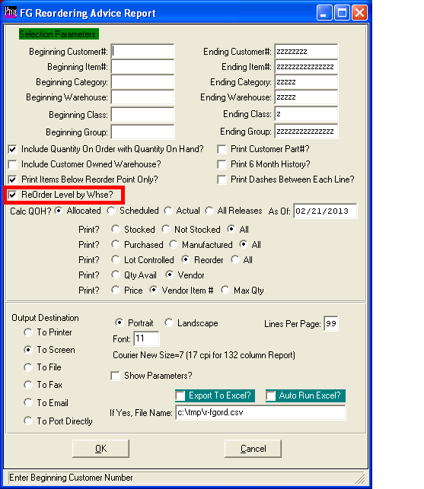

**N-K-1 REPORTS – View Form**

The I-R-1 Reorder Advise Report has an option to allow the user to select what fields will be printed or output to excel. Under the menu keys N-K-1, Reports parameter the user will define how the use selects the columns. For the reorder advise report, the business form must be set to IR1. If the logical value is unchecked, the user will select the fields from the report options above and the report will print as programmed by ASI. If the toggle box is checked, then the user can select what fields to print from the original report columns and the sequence of how the columns should print.

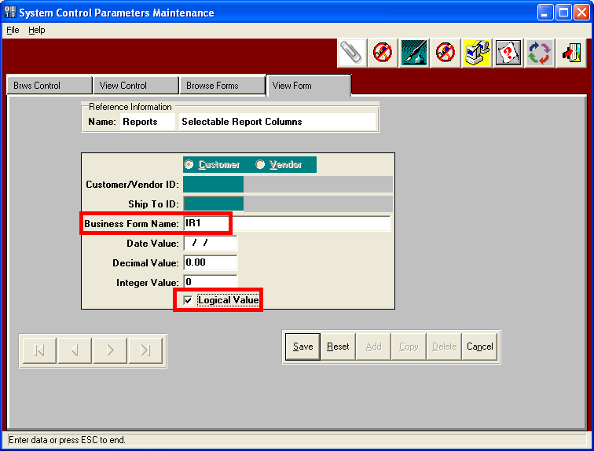

**N-K-1 REPORTS – View Form**

Below shows the report option when the NK1 Reports parameter, View Form business form IR1 logical value checked. Each user can select what fields to print from the originally programmed report columns and the sequence of how the columns should print. First, the user clicks the Select Columns button, then selects the fields in the box highlighted in green and click ADD to move the fields to the box on the right highlighted in red. Once the desired fields have been moved to the box on the right, the user can move the columns up or down until they have their desired sequence. Only the fields they the user wants to print will print or output to excel. Please note, the print selection ranges and other toggle boxes to pre sort the items prior to printing will remain the same. 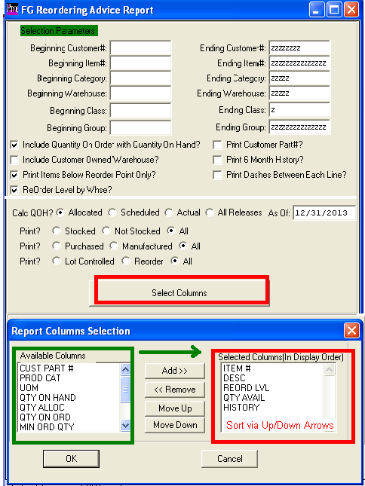**I-F-1 Inventory by Warehouse**

The finished goods inventory table allows defining reorder levels by warehouse. The reorder advise report has a toggle box to calculated inventory requirements by warehouse. If this toggle box is not checked, the report may show the inventory levels are adequate when in fact, a specific warehouse my be below levels sufficient to satisfy local customers demands.

The key to reordering by warehouse is to set reorder levels by warehouse for each item. The Advantzware software will update each warehouse when adding orders, updating release quantities and finished goods movements. The Inventory table now store quantities on hand, on order, allocated and available for each warehouse. In order to allocate inventory quantities by warehouse, the customer service representative must indicate what warehouse will deliver the product. The SHIPTO code added on the release will import the warehouse defined in the customers shipto file for automatic allocation by warehouse. However, the SHIPTO may be changed or multiple shipping locations may be added to the release screen, thereby updating the specific warehouses allocated quantity. Likewise, purchase order and jobs can now be

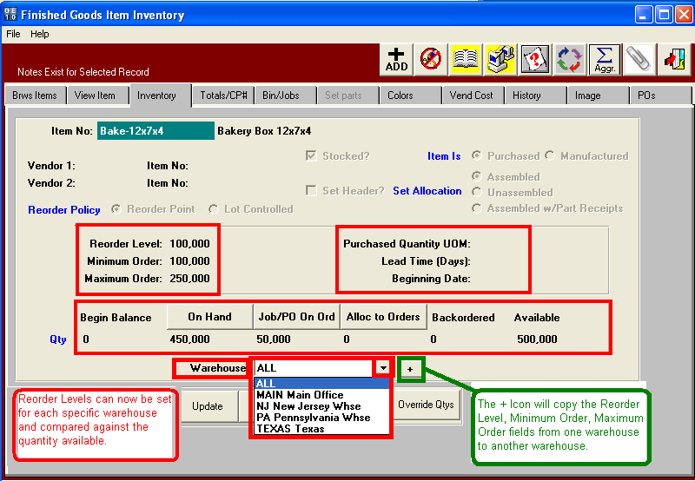

**I-F-1 Inventory by Warehouse**

The finished goods Bins/Jobs table will show a quantity on hand grand total of ALL warehouse or allow the user to select a specific warehouse to display the pallet tags on hand for each job.

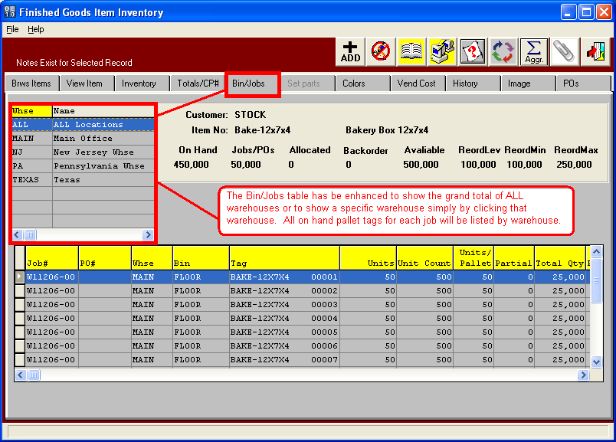

**O-U-1 Release by Warehouse**

The Release tab of order entry will import the warehouse location from the customer ship to file, but may be changed. The ship from warehouse defined is used to allocate the quantity on order by warehouse in the items inventory table. Adding , changing or deleting the release quantity will readjust the quantity allocated for that warehouse. Please not, the quantity ordered for the item when adding an order will allocate the warehouse called ALL. Do to job overruns and underruns, the quantity ordered may not match the total quantity of all releases , therefore the sum of allocated by warehouse may not match the quantity allocated for the ALL warehouse. If the release quantities match the order quantity then the sum of warehouses will match ALL warehouses. For example, if a customer orders 10,000 boxes, the quantity allocated is 10,000. However, if we produce 11,000 and have multiple releases that total 11,000, each release will update only that warehouse without affecting the original order quantity allocated.

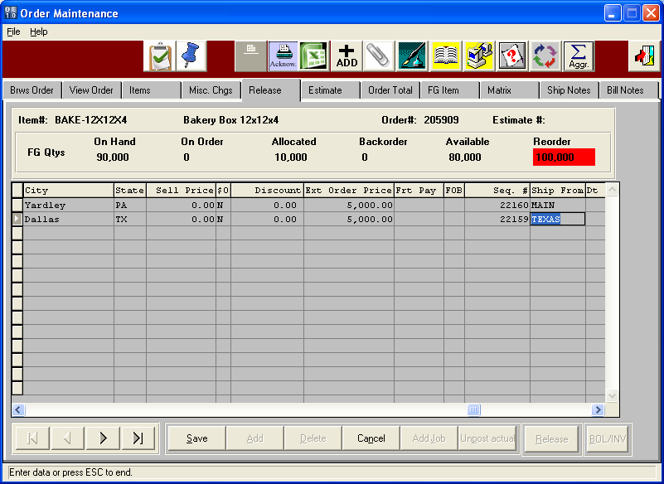

**Inventory Control by Warehouse**

Finished Goods warehouse transactions including receipts, transfers, cycle counts and bill of ladings have always updated our inventory by warehouse. Now the balances by warehouse can be compared to reorder levels by warehouse.

